TECOPS-2201

From Zero to Hero:

Cisco Network Services Orchestrator (NSO)

Intermediate

Sofia Athanasiou - Customer Success Specialist

Hector Oses – Customer Delivery Software Architect

Learning Objectives or Table of Contents [Heading 1]

Upon completion of this lab, you will be able to:

* One
* Two
* Three…

Disclaimer

This training document is to familiarize with [xzxzxzxzxzxzxzxzxzx]. Although the lab design and configuration examples could be used as a reference, it’s not a real design, thus not all recommended features are used, or enabled optimally. For the design related questions please contact your representative at Cisco, or a Cisco partner.

Scenario

In this lab activity, you will learn how to … Lorem ipsum dolor sit amet, consectetur adipiscing elit. Duis ac est lectus. Fusce nec est dolor. Suspendisse vel ornare ligula. Sed blandit lacus eu nulla scelerisque semper. Donec maximus turpis vel massa molestie iaculis. Nam nec lacus luctus, vestibulum ex non, convallis elit. Pellentesque habitant morbi tristique senectus et netus et malesuada fames ac turpis egestas. Mauris ultrices lorem mauris, eu dictum ante iaculis ut. Suspendisse potenti. Aliquam ullamcorper, nisl eu vestibulum molestie, nibh est volutpat sapien, sed viverra est lectus ac nisl. Morbi rhoncus sagittis nisl id congue. Pellentesque eleifend lectus tellus, nec suscipit nisi tincidunt accumsan. Nam turpis leo, eleifend ut vehicula sed, sollicitudin at tellus. Duis tincidunt felis lacus, a accumsan enim tincidunt consectetur. Donec sollicitudin tincidunt eros in volutpat. Etiam a imperdiet purus.

# Network Diagram

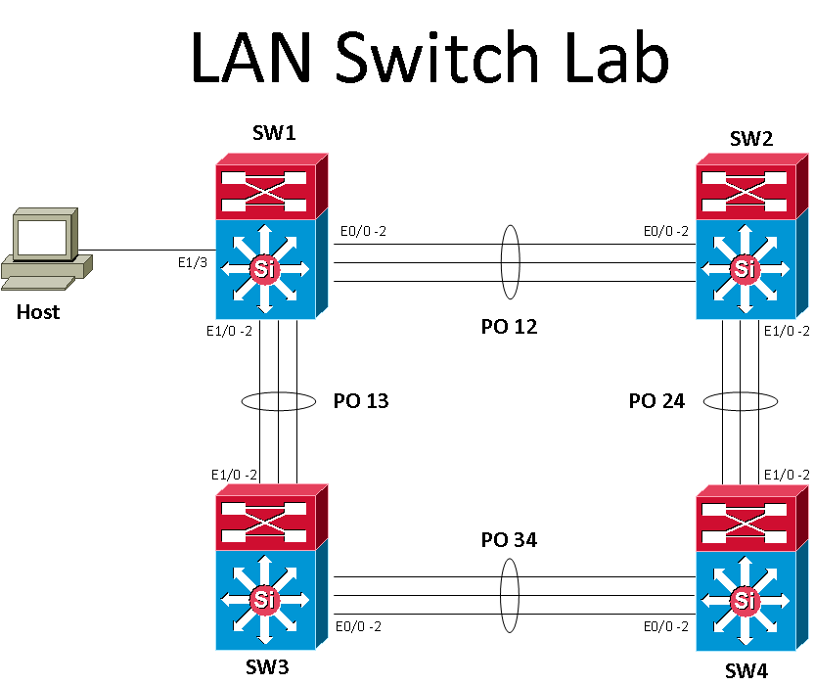

Task 1: [Task Action Subtitle]

[Task Action Instructions] Lorem ipsum dolor sit amet, consectetur adipiscing elit. Duis ac est lectus. Fusce nec est dolor. Suspendisse vel ornare ligula. Sed blandit lacus eu nulla scelerisque semper. Donec maximus turpis vel massa molestie iaculis. Nam nec lacus luctus, vestibulum ex non, convallis elit. Pellentesque habitant morbi tristique senectus et netus et malesuada fames ac turpis egestas. Mauris ultrices lorem mauris, eu dictum ante iaculis ut. Suspendisse potenti.

Step 1: Configure… [Task Step by Step Instructions]

[Provide detailed steps to complete the task] Nam nec lacus luctus, vestibulum ex non, convallis elit. Pellentesque habitant morbi tristique senectus et netus et malesuada fames ac turpis egestas. Mauris ultrices lorem mauris, eu dictum ante iaculis ut. Suspendisse potenti. Aliquam ullamcorper, nisl eu vestibulum molestie, nibh est volutpat sapien, sed viverra est lectus ac nisl. Morbi rhoncus sagittis nisl id congue. Pellentesque eleifend lectus tellus, nec suscipit nisi tincidunt accumsan. Nam turpis leo, eleifend ut vehicula sed, sollicitudin at tellus.

Step 2: Configure/Verify… [Task Step by Step Instructions]

[Provide detailed steps to complete the task] Nam nec lacus luctus, vestibulum ex non, convallis elit. Pellentesque habitant morbi tristique senectus et netus et malesuada fames ac turpis egestas. Mauris ultrices lorem mauris, eu dictum ante iaculis ut. Suspendisse potenti. Aliquam ullamcorper, nisl eu vestibulum molestie, nibh est volutpat sapien, sed viverra est lectus ac nisl. Morbi rhoncus sagittis nisl id congue. Pellentesque eleifend lectus tellus, nec suscipit nisi tincidunt accumsan. Nam turpis leo, eleifend ut vehicula sed, sollicitudin at tellus.

**Table:** Lorem ipsum dolor sit amet

|  |  |  |  |
| --- | --- | --- | --- |
| Lorem ipsum | Lorem ipsum | Lorem ipsum | Lorem ipsum |
| Lorem ipsum | 1 | Lorem ipsum | Lorem ipsum |
| Lorem ipsum | 2 | Lorem ipsum | Lorem ipsum |
| Lorem ipsum | 3 | Lorem ipsum | Lorem ipsum |
| Lorem ipsum | 4 | Lorem ipsum | Lorem ipsum |

Related Sessions at Ciscolive

You can search CiscoLive Amsterdam content catalog with specific keyword and recommend sessions that are relevant to your lab.

[Content Catalog Link](https://www.ciscolive.com/emea/learn/sessions/content-catalog/)

XYZ Troubleshooting [BRKABC-2000] Name of the Speaker, Technical Leader, Cisco

Summary

Appendix A is designed to familiarize you with the startup process of discovering the fabric and viewing each of the physical components of the fabric. This test also allows you to get familiar with navigating through the Fabric view of the APIC GUI. This is the first critical step in building up the ACI environment and will be the baseline infrastructure to build up your application network.